|  |
| --- |
| Close-up image showing the leaf-sides of two oversized books side-by-side on a bookshelf, with additional books in soft focus background |
| Irish Train APP  Student Email: x15007669@student.ncirl.ie |
| |  |  |  | | --- | --- | --- | | Surendra Dura | 10/14/18 | Multimedia and Mobile App Development | |

Contents

Introduction: 2

Problem that you are addressing or the target audiece: 2

3 app on the Irish rail timetable: 2

1. Irish rail (online@irishrail.ie, 2013): 2

Screenshots: 2

Good features: 4

2. Next Dart (egrappsmob@gmail.com, 2013): 4

Screenshots: 4

Good features: 6

3. Train Track (jessy.cnr@gmail.com, 2018): 6

Screenshots: 6

Good features: 9

Innovation in My App: 9

Bibliography 9

# Introduction:

I want to develop an android Irish rail app to show the time table of the Irish rail and there will be news field on the app like the first page of the Facebook so that people can upload the feedback or problem will be uploaded which help to the users. And I would like to map on my app, so users can see the live rail moving on the track. If the feedback section, have uploaded new thing then the user get notification on the app. Also, I would like to put information for the user like how to use the train by leaf card or ticket.

# Problem that you are addressing or the target audiece:

There was few app like Irish rail, next Dart, Irish Rail Live, Train Track and soon. I have seen that this app has features to show the timetable but does not have information and the feedback section. That’s why sometime, the app shows the train timetable, but the real time table is not updated on the app. I am the regular user of the Irish dart. Sometime there was technical difficulties on the dart and dart is late, but the app still shows me the same time and when I went to the dart station, they’re was the display or announcement that dart is late by 30 mins or not working between 2 or 3 hours.

On the other hand, due to game or concert in the Aviva stadium, the dart was late or too much passengers in the dart which was not inform to the users. Also, for the Maynooth or Drogheda user, their train always started from the Pearse Station, but sometime is started from the Dublin Connolly station which was not updated in the app, so the passenger missed the train and they must wait up to 1 hours.

# 3 app on the Irish rail timetable:

# Irish rail (online@irishrail.ie, 2013):

This is an official app which help user to plan the journey, view the timetable of the dart and see the live train on the station.

## Screenshots:

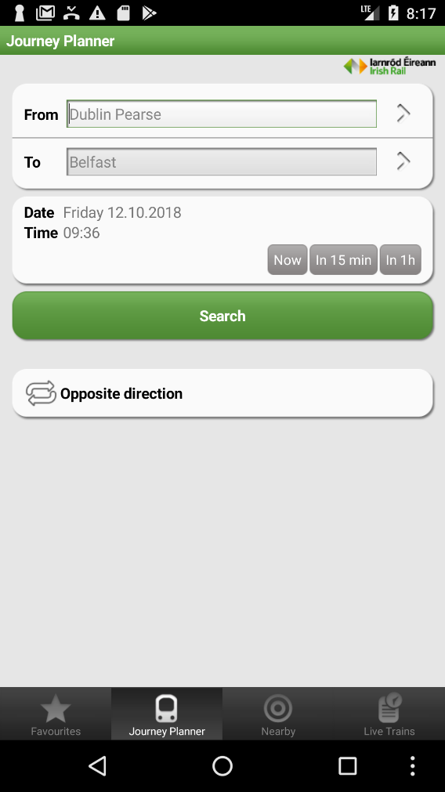 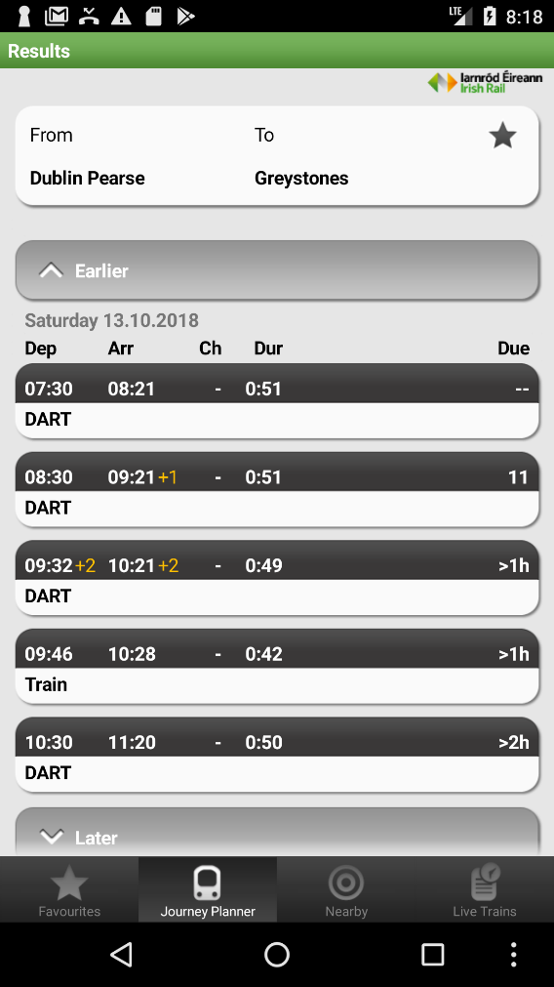

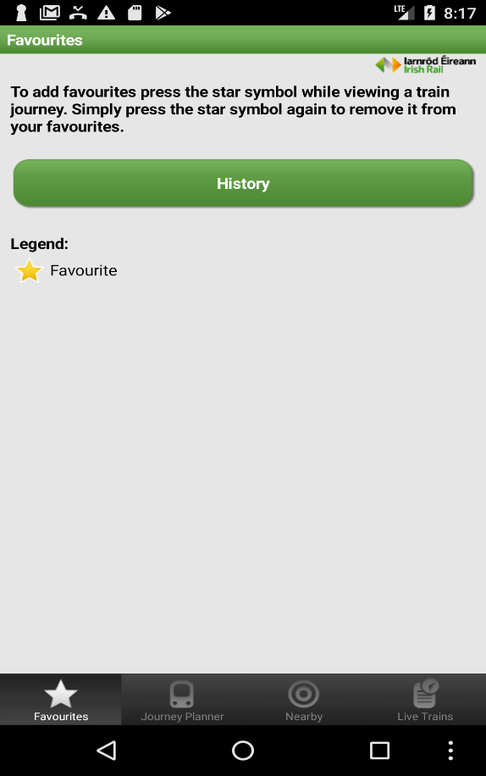 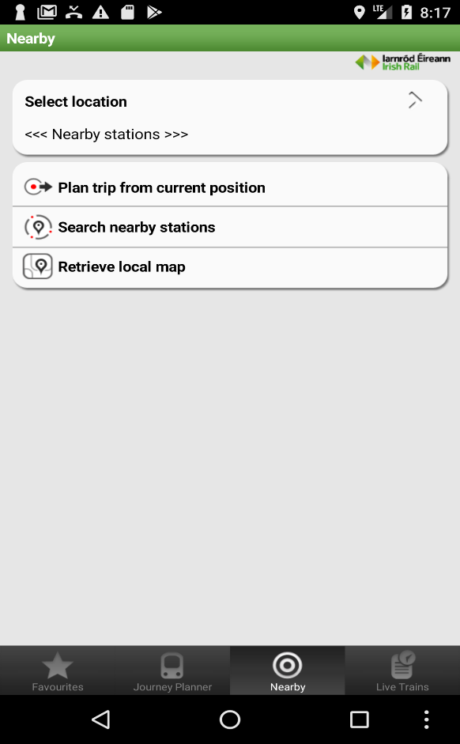

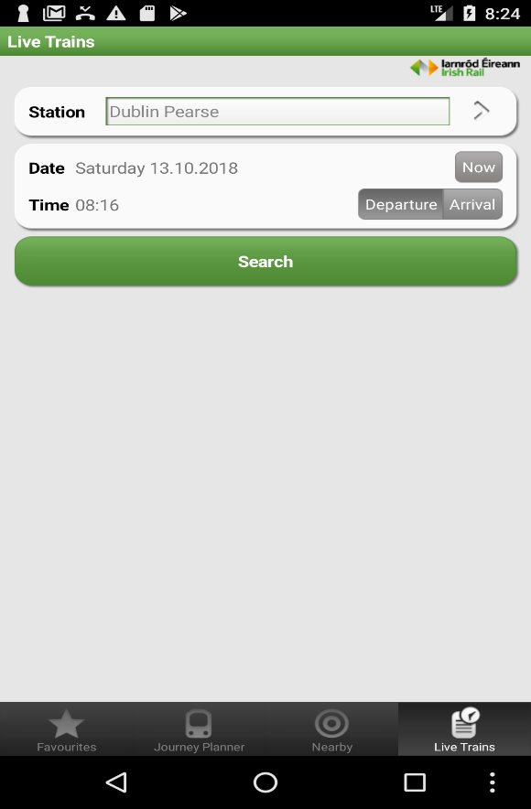 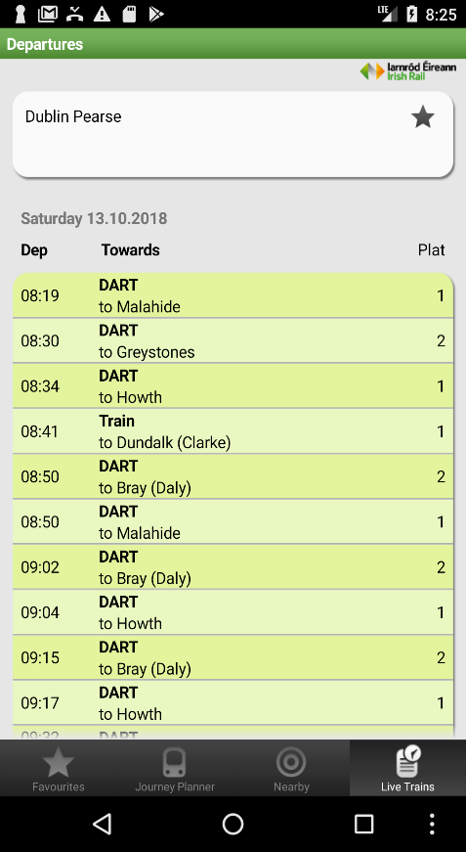

### Good features:

* I have the four tabs like favorites, journey planner, nearby station and live trains.
* When I search the live train by station, it shows the date and time including platform number along with destination.
* Journey planer help me to select the destination and the date and time. It has opposite direction button which help me to reverse the destination.
* Favorites help me to put the favorites train station to use on the future.

# Next Dart (egrappsmob@gmail.com, 2013):

It is a simple app it only shows the next dart on that station for the northbound or for the southbound. It has the twitter of the official Irish Rail.

## Screenshots:

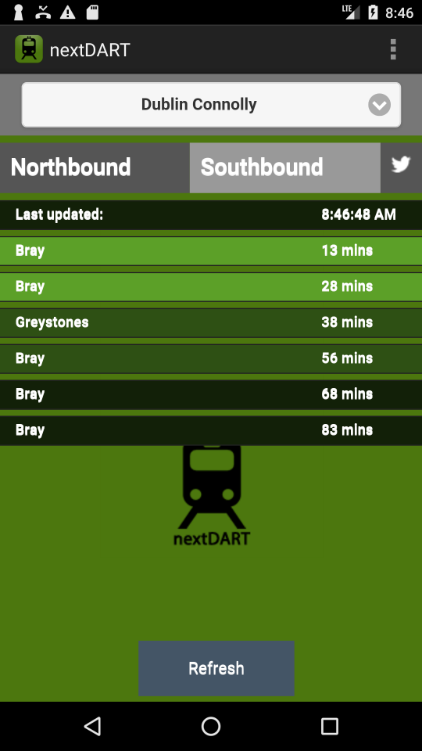 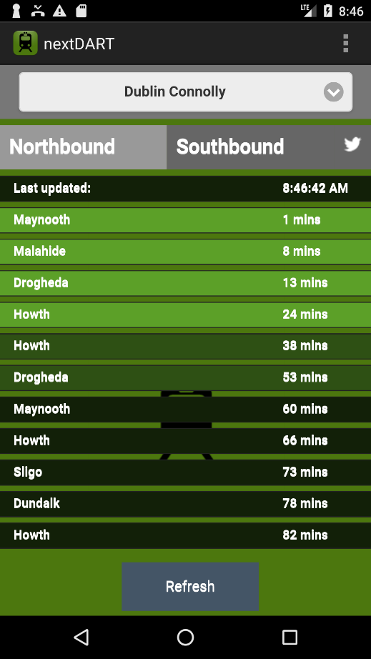

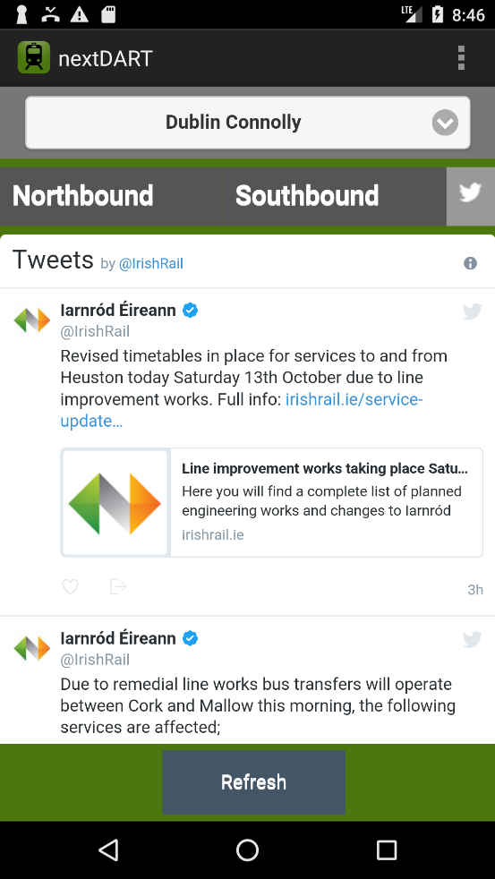 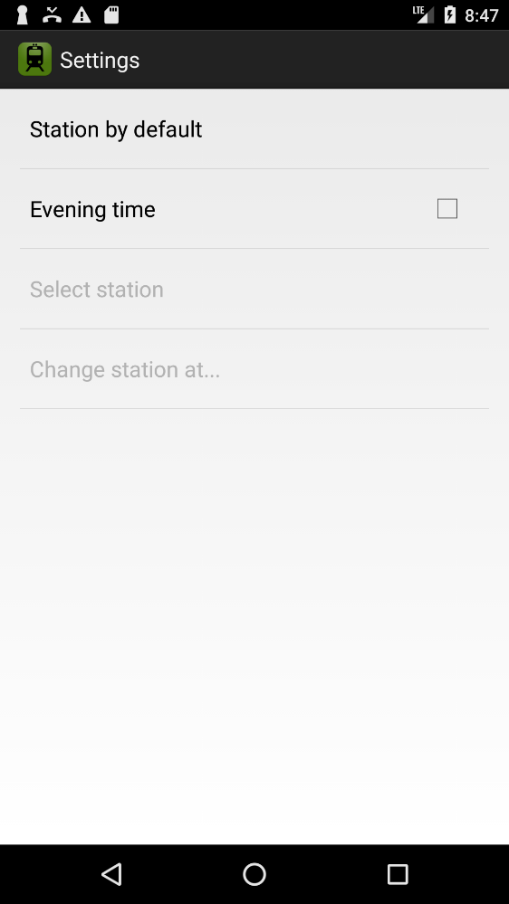

### Good features:

* By using setting button on the top of right-hand corner, to save the station.
* It is only 3 tabs so easy to use.
* It separates the north and south bound so used did not get confused.
* It shows the destination location and time on the app.
* It has official twitter of Irish rail.
* It has refresh button on the down to refresh the time.

# Train Track (jessy.cnr@gmail.com, 2018):

It is an app to track the Irish rail by using the station which includes the simplistic design show the all the stop station of the dart.

## Screenshots:

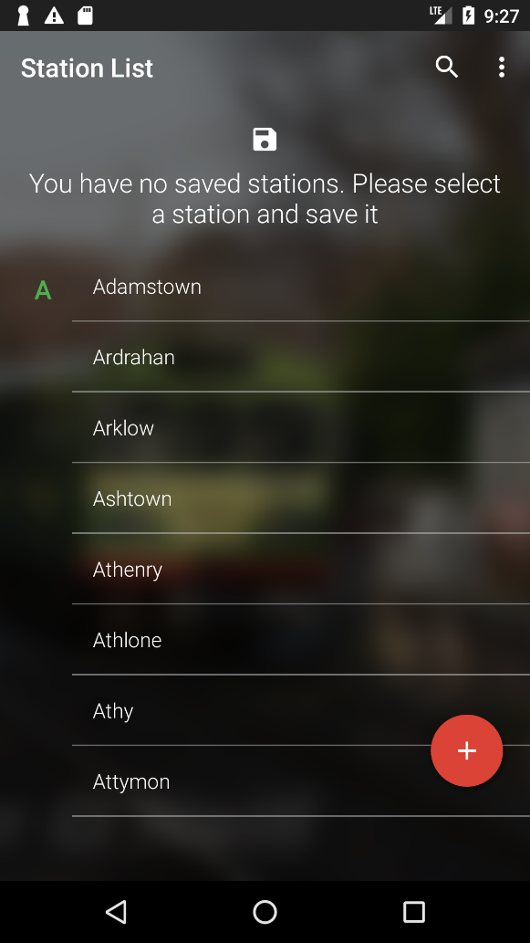 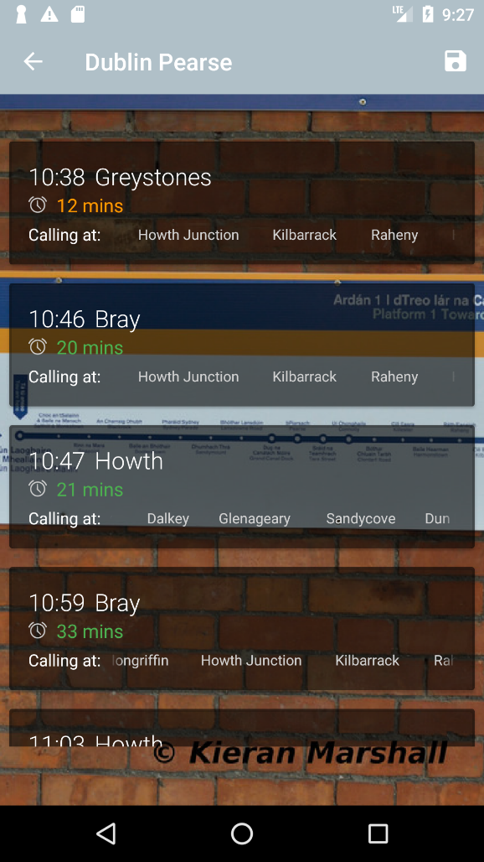

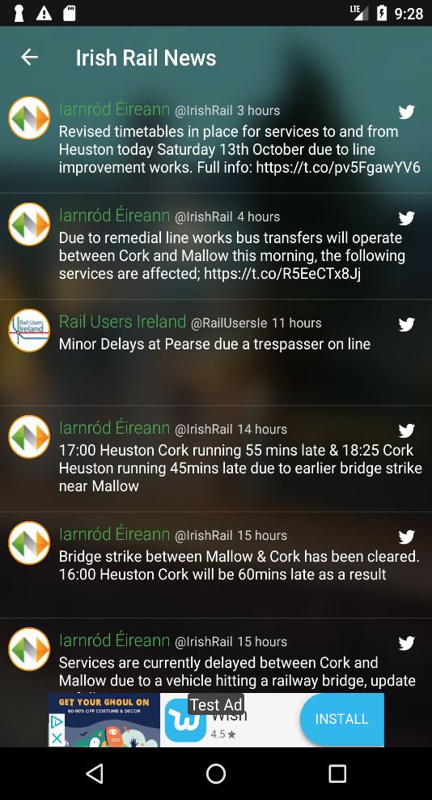 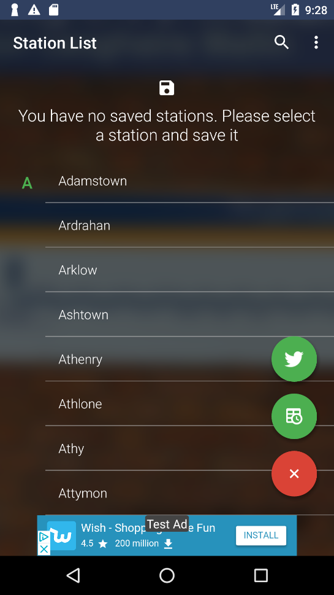

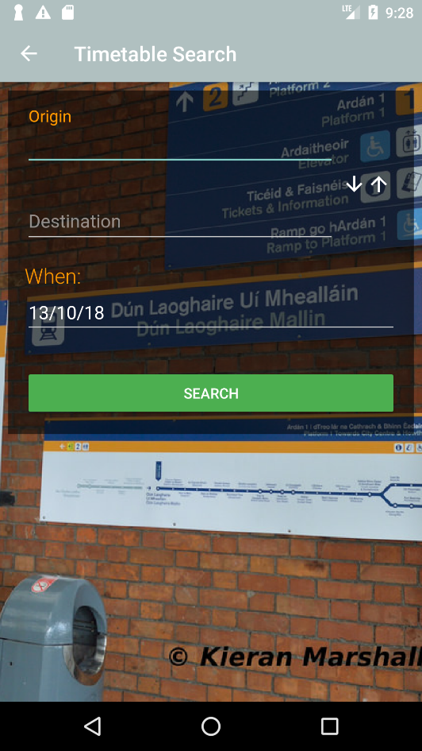 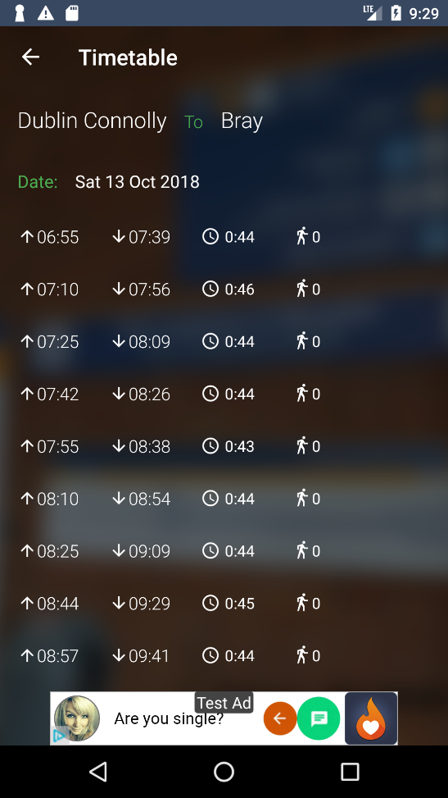

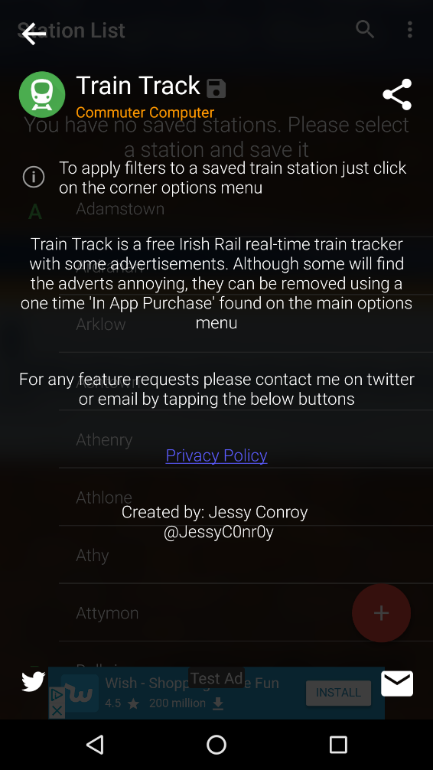 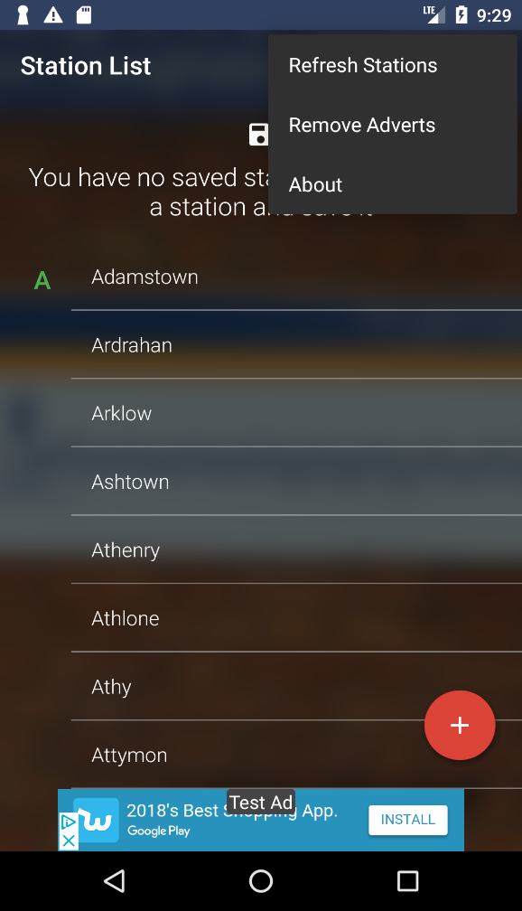

### Good features:

* It has the search bar as well as station by the starting letter.
* It has plus icon which has twitter of Irish rail and the time search table.
* It shows the time and the destination of train with the calling station.
* We can save the station and easy to search the station in future.

# Innovation in My App:

I gone a combine all the different feature of app and I would also input Facebook page of Irish rail and I would have news field tab, so the user can upload the problem or the updated on the Irish rail like Facebook or Instagram page. And If the used save the station as a favorite then they can get notification if the something problem happen on that station like train is not working or delay by this much time. I would like to zoom in or zoom out, so the older people can see the word correctly.

# Bibliography

egrappsmob@gmail.com. (2013, October 1). *Next Dart*. Retrieved from Play Store: https://play.google.com/store/apps/details?id=com.egrapps.nextdart

jessy.cnr@gmail.com. (2018, April 3). *Train Track (Irish Rail & Dart services)*. Retrieved from Play Store: https://play.google.com/store/apps/details?id=com.developer.jessyconroy.traintrack

online@irishrail.ie. (2013, June 4). *Irishrail app*. Retrieved from PlayStore: https://play.google.com/store/apps/details?id=de.hafas.android.irishrail